Pass for level 4: Z9tkRkWmpt9Qr7XrR5jWRkgOU901swEZ

Step 1: In the source code we can see:

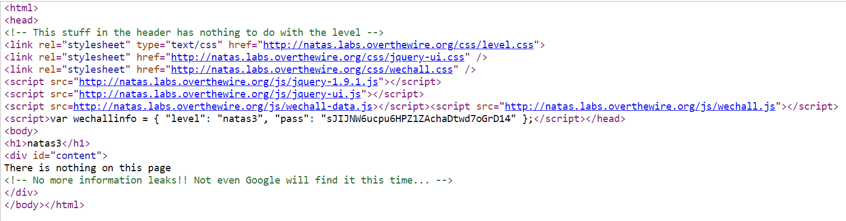

Hence I understand that my hope will not comes from there.

Step 2:Check for robots.txt instructions then I enter "<http://natas3.natas.labs.overthewire.org/>robots.txt"

This will let us know what the owner of the website tells to robots where not to look for.

